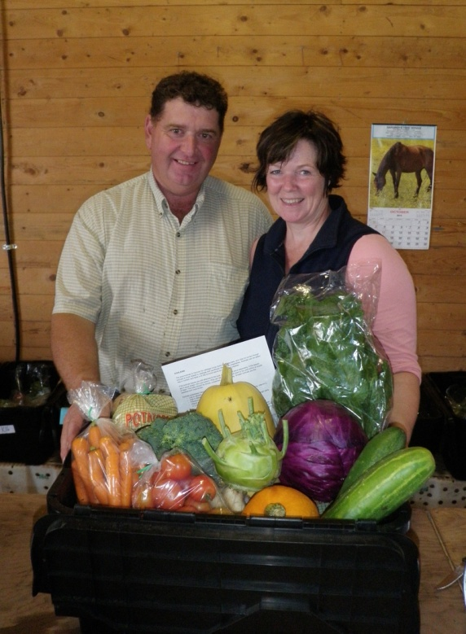
Crystal Green Farms
2377 Route 112
Lower Bedeque PEI
greengfarms@yahoo.com

Crystal Green Farms is a certified organic farm located in Bedeque in Prince Edward Island.
Operated by Brian Mackay and Kathy Ware, Crystal Green Farms grows organic vegetables as well as oilseed crops and grains. We also naturally raise calves, a flock of sheep, pigs, and chickens for both meat and eggs.
Our core business is our Veggie Box program, where we provide fresh organic veggies to customers in Summerside and Kensington and a recent new delivery area in Winsloe.
You can also pick up your veggie box at our booth at the Summerside Farmers Market each Saturday morning from 9am - 1pm.
Crystal Green Farms currently has approx.165 acres in certified organic production since 2010.
