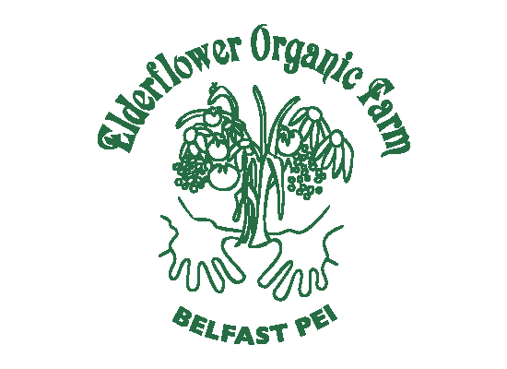Elderflower Organic Farm
Selkirk Road
Valley, PEI
(902) 659-2098

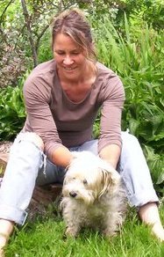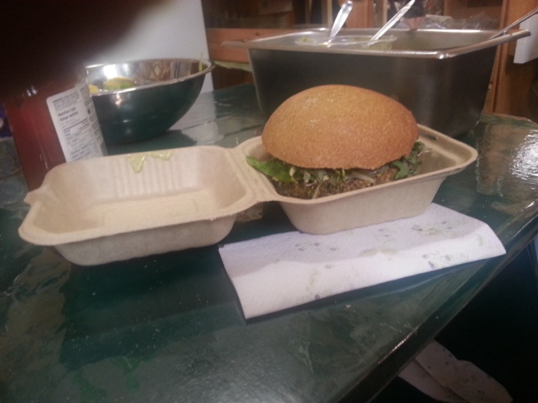

Margie Loo has been farming this land in Valley for 13 years, her farm has evolved over the years to produce original value added products. Margie has greenhouses to extend the growing season. She uses some of her vegetables to produce veggie burgers and sausages, and fruit to create treats which she sells at the Charlottetown Farmers Market. She also sells to local restaurants.

